Create table t1(sno int ,

Sname varchar(100),

City varchar(100),

Comm int,

Primary key(sno));

Create table t2(cno into,

Cname varchar(100),

City varchar(100),

Rating int,

Sno int,

Foreign key (sno) refrences t1(sno));

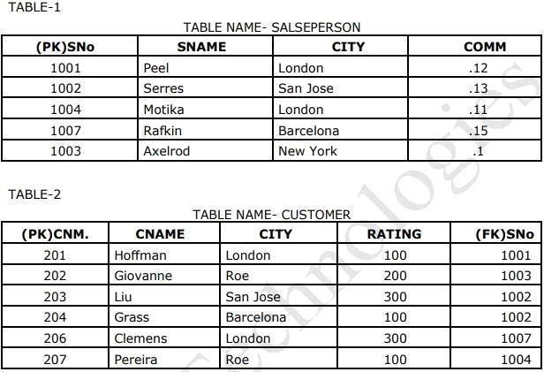

Select \* from t1 where comm=>.13;

Sno sname city comm

1001 peel London 0.13

1002 serees san jose 0.14

1007 acerod newyork 0.15

Select name,city from t1 where city=”London” and comm=>10;

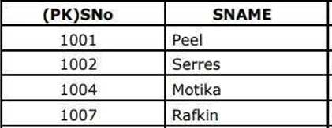

Select name from ta,t2 where city=”Barcolean” or city=“london”

Name

Peel

Motina

Rafkin

Hoffman

Grass

Clements

Select name from t1,t2 where comm=.10 between cpmm=.12

Name

Peel

Motika

Select \* from t2 where rating>=100;

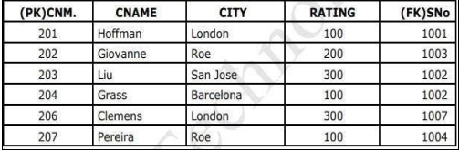

Select count (sno) from t1;

=6